# **Project 1 – Developing photo gallery app**

**Learning outcome:** After completion of Project 1, students should be able to reuse code efficiently by utilizing props and effectively route data to various components within the React App.

**Estimate time to complete project 1: 2+ hours**

**Project Description:** Project 1 involves creating an app showcasing images organized in various paths within the application, all with a consistent card design. Users should be able to navigate between different sections of the app using <Link> components embedded in text and within cards. The choice of topic is open-ended. For instance, if the theme is centered around nature photography, the app could be named "Explore Nature," featuring sections like Home (accessible via an icon), Stars and Trees, Walk with Nature, and Beauty of Nature Speaks, each accessible through distinct navigation links and card content within the app:

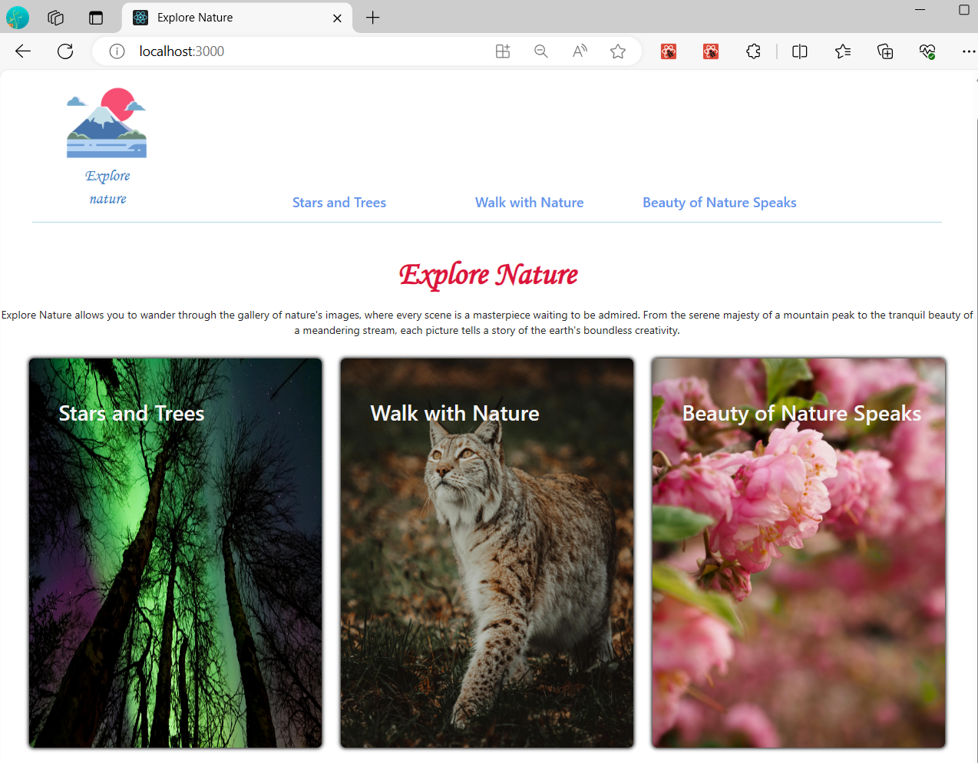

For example, if I click on "Stars and Trees" either from the navigation tab or from the card content, it should route me to the corresponding page dedicated to "Stars and Trees."

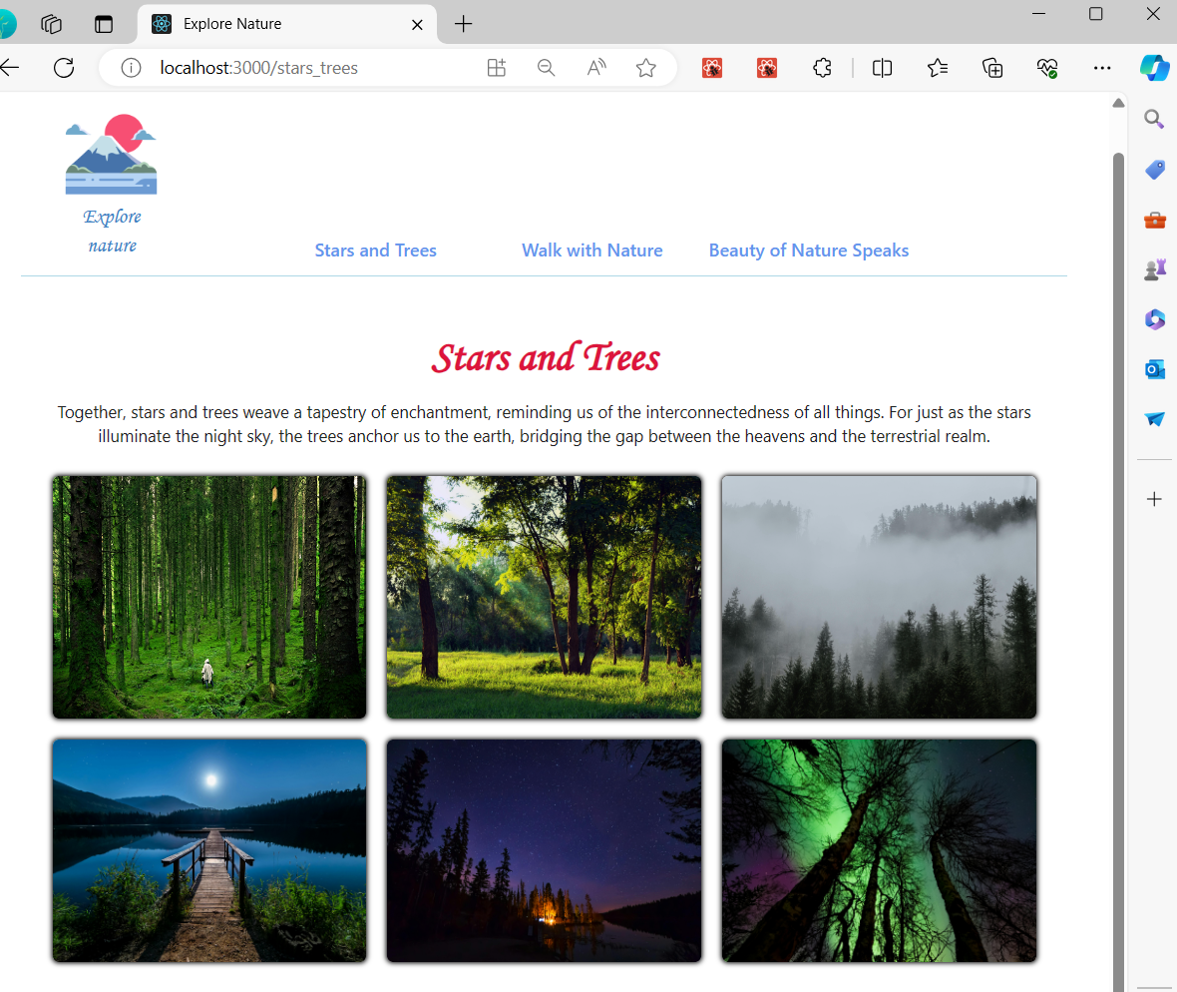

The app should feature a unified card design, implemented through props, across all paths within the application. It should display three distinct types of images, all adhering to the same card design, and transition between individual pages while maintaining consistency using props. This file must be saved as ***card.js.*** For instance, all three different pages within the app, along with the homepage, should employ the same card design:

*Home page view*

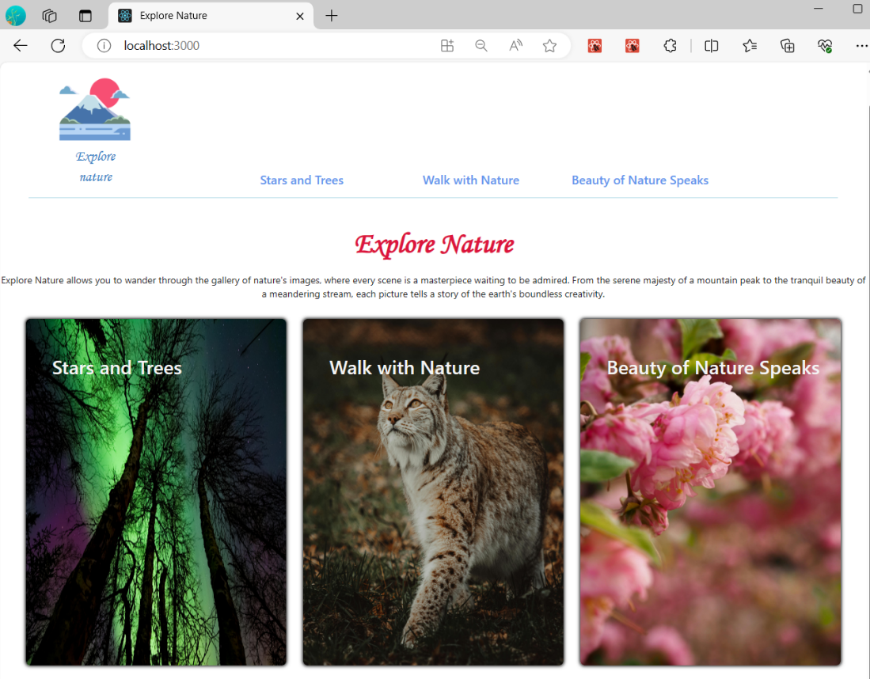

*Stars and Trees* view



*Walk with Nature* view

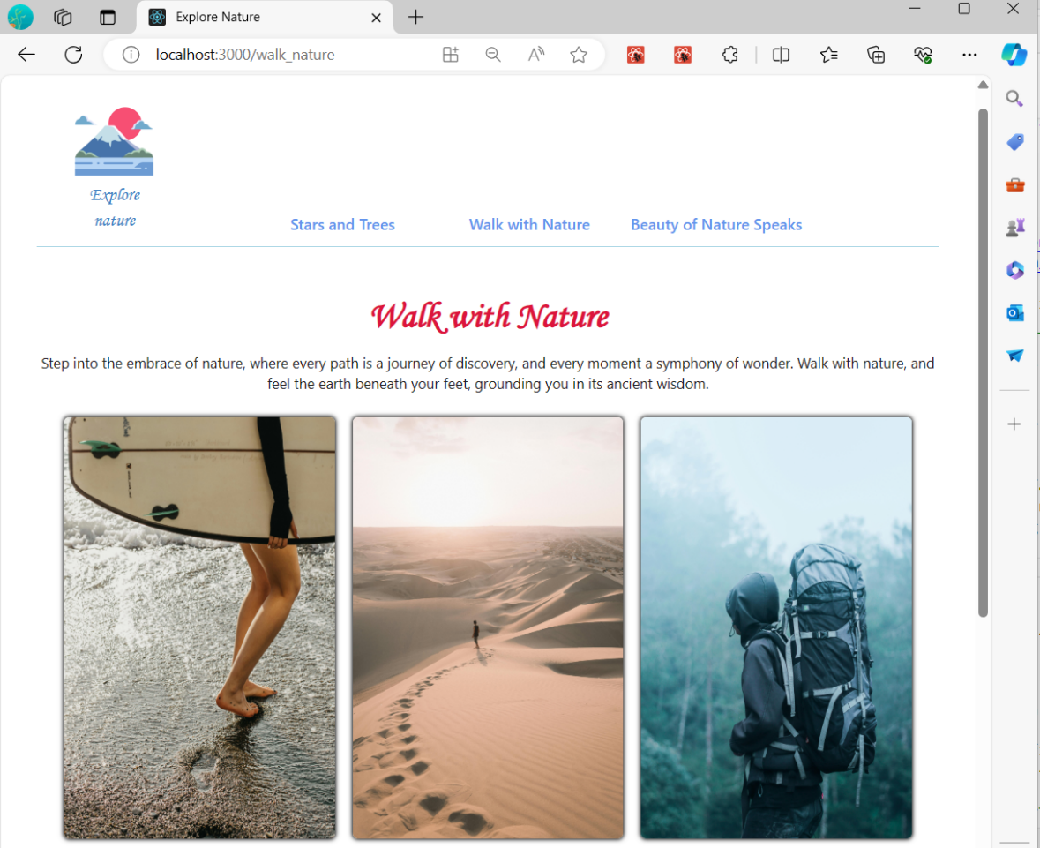

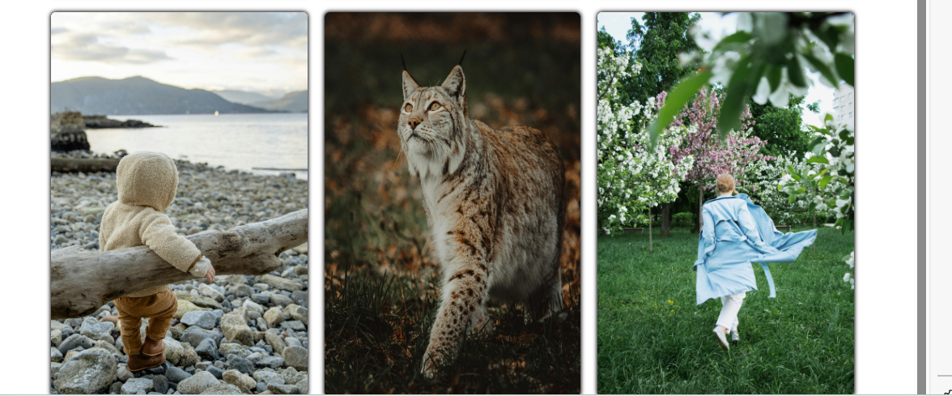

*Speak with Nature* view

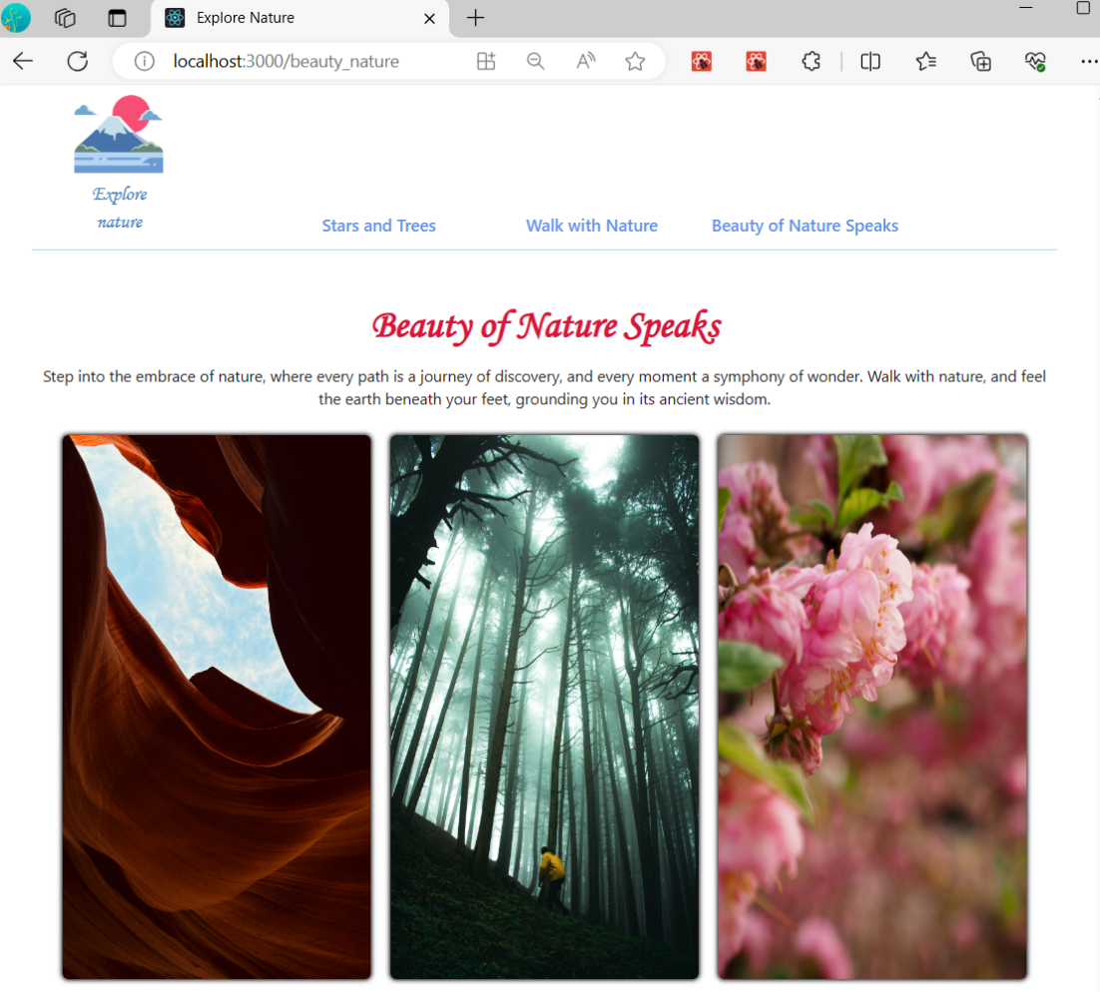

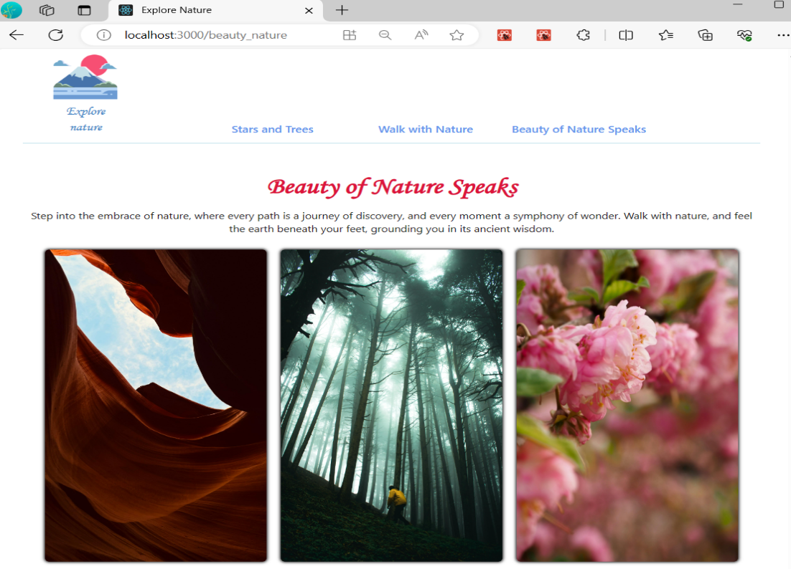

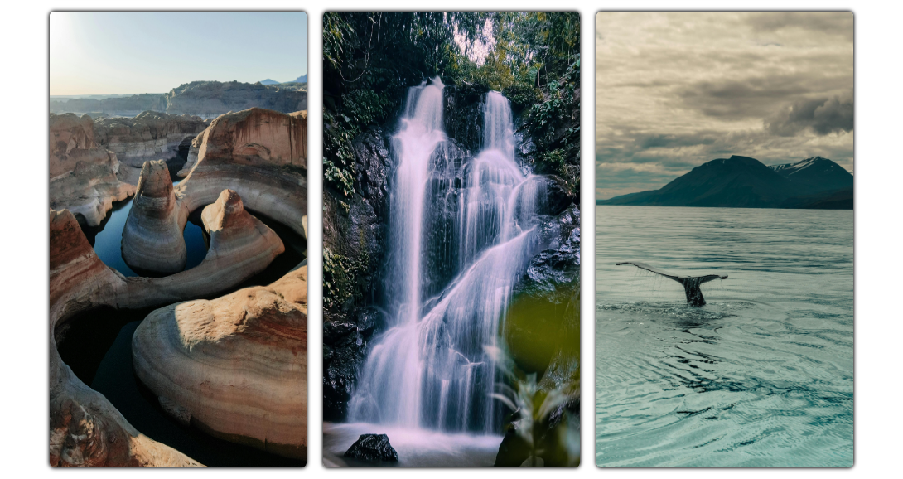

**Project Grading:**

* Routing design for a <Link> in navigation tab: 15 pts
* Routing design for a <Link> in a card: 15 pts
* Creation of card.js file: 4 pts
* Design of card.js to replicate the cards in each page: 20 pts
* Creation of three different pages and a home page: 12 pts (3 pts per page)
* Each page should have a title, an introduction paragraph, and at least six different images: 16 pts (4 pts per page)
* Submission on time: 10 pts
* App styling: 8 pts + 10 extra pts.
* Total points: 100 + 10 extra

**Submission:**

Zip and submit the zipped **src** folder through Blackboard.